Lesson 4 Demo 6: Parameterized Builds

This section will guide you to:

* Configure parameterized builds in Jenkins

This lab has two sub-sections, namely:

1. Configuring a parameterized build in Jenkins

2. Building a project with parameters in Jenkins

**Step 1:** Creating a parameterized build

* Go to Jenkins **dashboard**.
* Click on ***New Item***.
* Enter a **name** for your build job.
* Select ***Freestyle project***as the build job type.

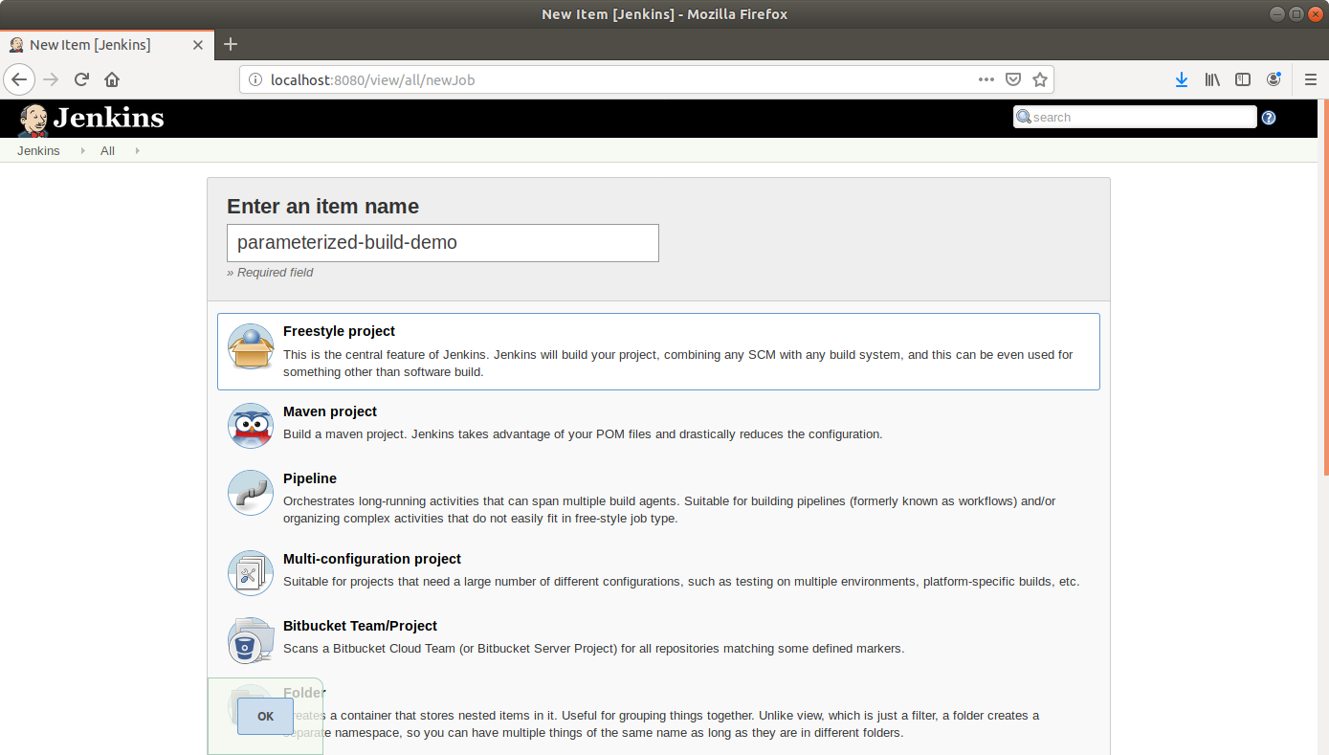

* Click **OK**.
* On the configuration page, **select** the checkbox next to text that states,***This project is parameterized*.**
* Click on the ***Add parameter*** button.

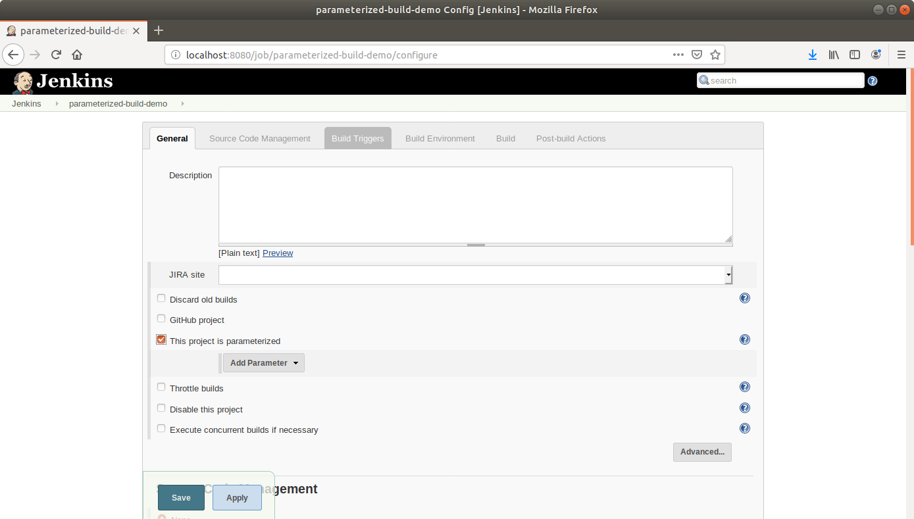

* From the drop-down menu, select ***Boolean parameter***.
* Name the Boolean parameter ***generate_javadoc*** and enable the ***Default Value*** checkbox.

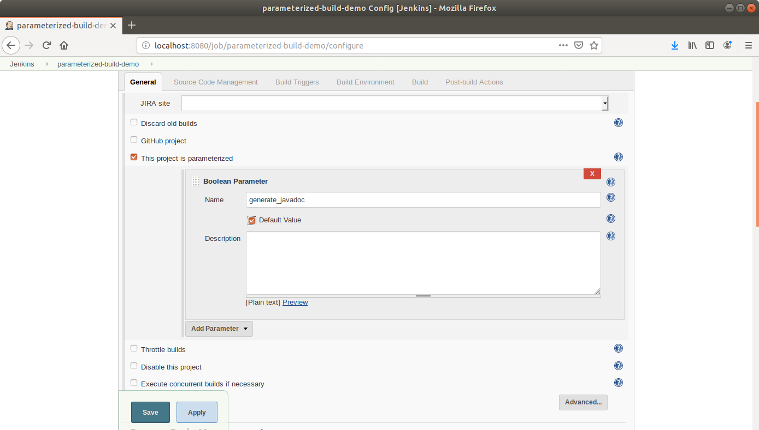

* Click the ***Add Parameter*** drop-down list again and choose a string parameter. Name this Jenkins build parameter ***javadoc_location*** and give it a default value(/home/labuser/).

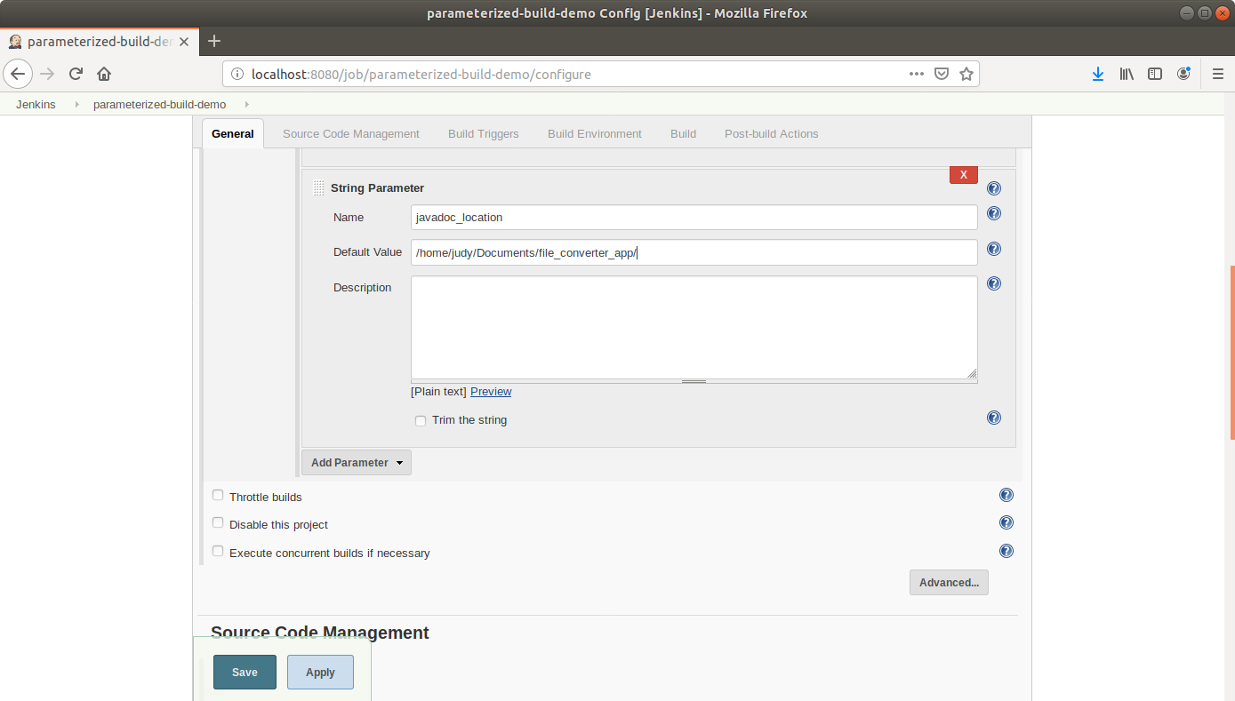

* Scroll down to the***Build*** section and click on ***Add build step***.
* Select***Execute Shell Command***from the drop down that appears.

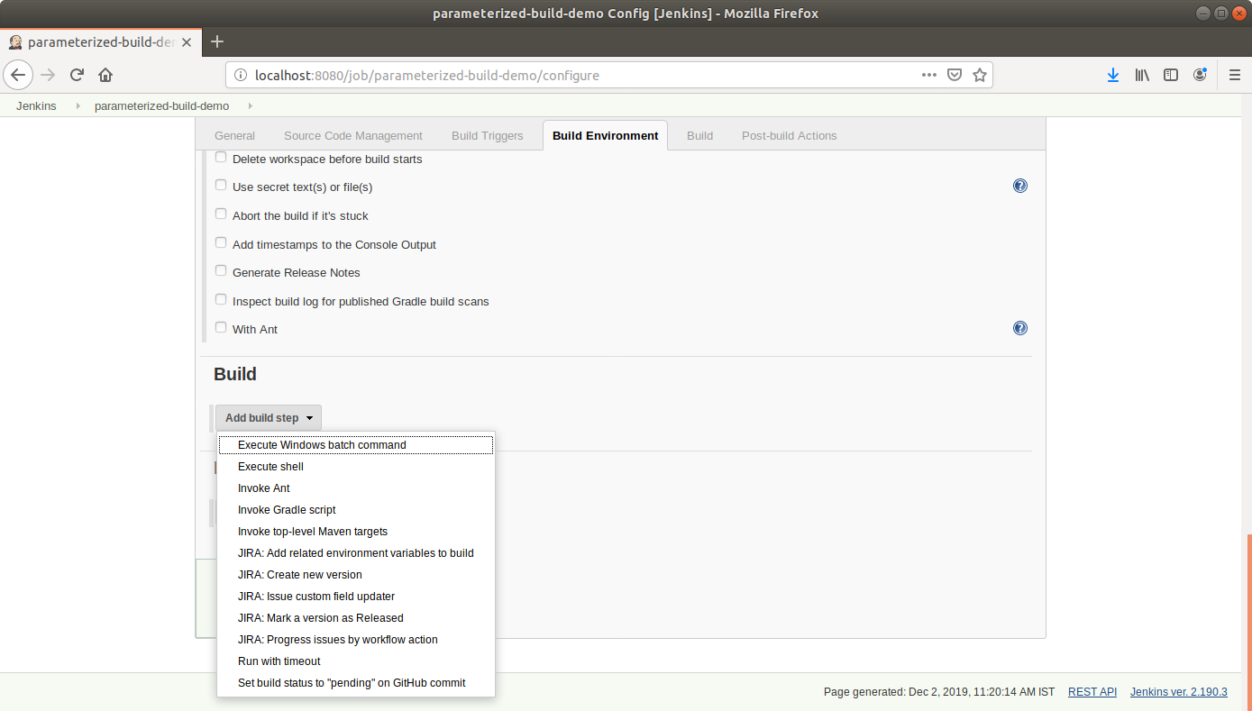

* In the text input area, enter the following text:

**echo $generate_javadoc**

**echo $javadoc_location**

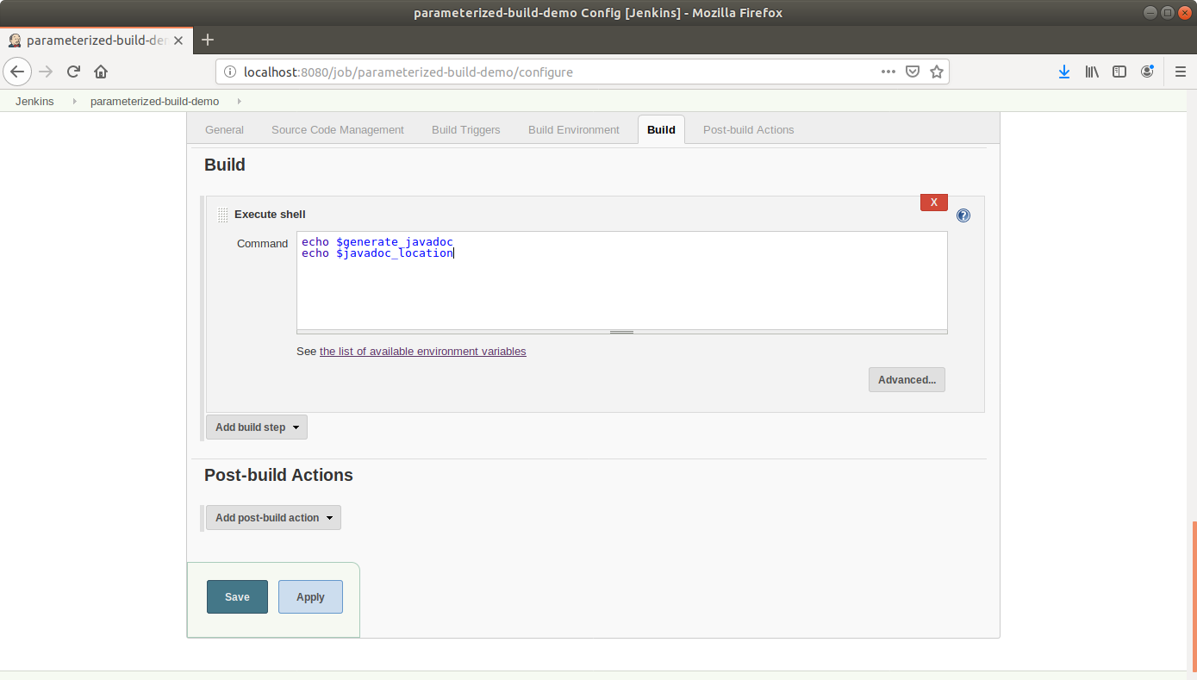

* Click **Save**.

**Step 2:** Building a project with parameters in Jenkins

* Click ***Build With Parameters*** in the project window to make sure the build works.

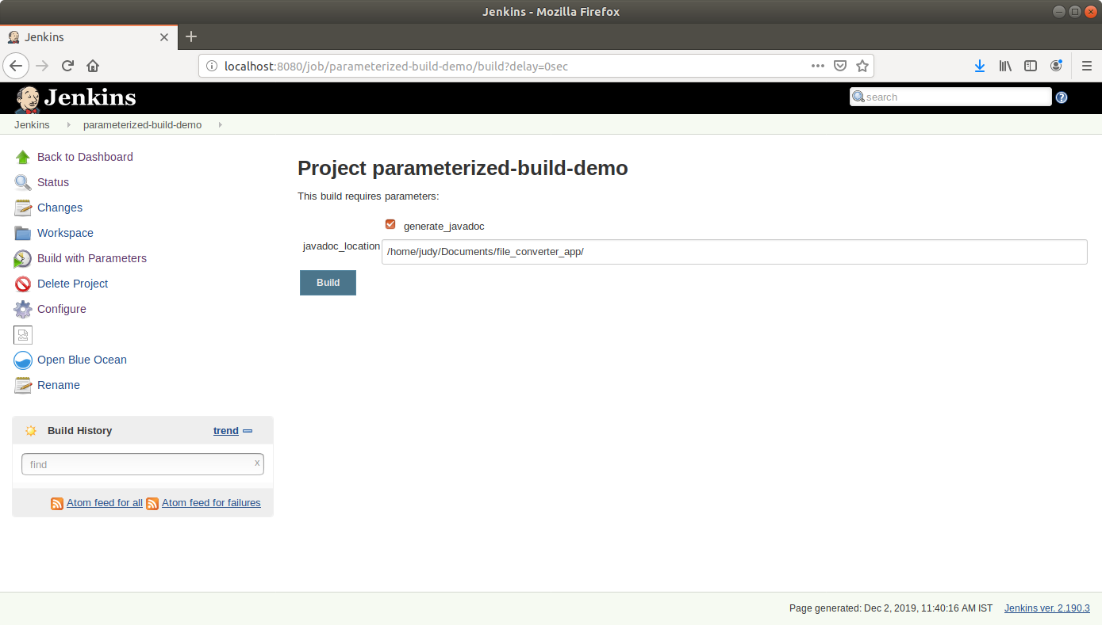

* In the page that appears, accept the defaults and click the ***Build*** button. Jenkins will now build your project.
* Click on the ***Build History***to view the build results.
* Click on the ***Console Output*** to view the build logs.

